**DCIT 206 ASSIGNMENT 2**

**10841867**

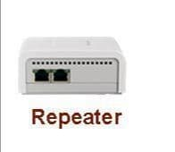**Repeater**

The **repeater** as shown here functions at Physical Layer. What this means is that it is responsible for sending computer bits to a device from another device along a network. The repeater also known as an extender is an electronic device that amplifies received signals at a higher level. Essentially, it is a gizmo that gives network signals a significant boost so they can reach or travel farther and cover longer distances. They consist of two ports and connect two devices.

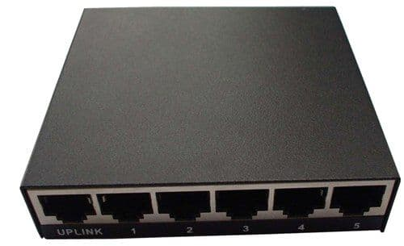**Hub**

The **hub** is essentially a repeater but with a lot more ports. It is a device used for connecting multiple Ethernet-based devices. They work at the physical layer, that’s layer 1 of the OSI model. This node transmits data to the Ethernet devices connected to it. It is less sophisticated than a switch due to its inability to isolate data transmissions although they participate in the detection of a collision. They are best suited for small-scale and simple local area network environments. The active hub, an Ethernet hub, network hub, repeater hub, and concentrator are all hubs.

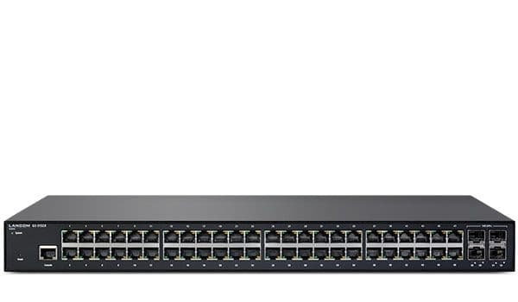**Switch**

The **switch** functions at the data link layer, that’s layer 2 of the OSI model. This means it transfers data among nodes on a network segment and this is across the physical layer. Being a networking hardware, and commonly referred to as a network bridge, the switch connects devices on a computer network, receiving and forwarding data to target devices using packet switching. It uses MAC addresses to send data. Some switches process data at the network layer. These are known as Layer 3 switches or multilayer switches (layer 3 and above).

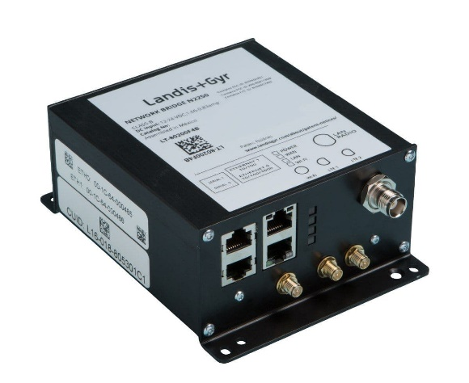**Bridge**

The **bridge** isa network hardware that connects several network segments at Layer 2 of the OSI model, that is the data link layer. Switches and bridges are very much alike with a switch being a multiport bridge. They establish a single but aggregate network from multiple network segments or communication networks. This is known as network bridging. They can also analyze received data packets and determines if it’s capable of forwarding it to another network segment.

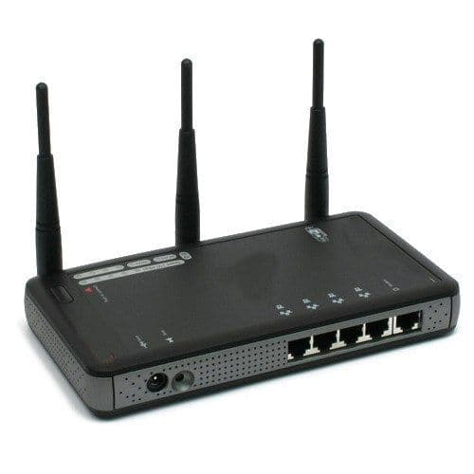**Router**

**Routers** function as a switching device for networks. They route network packets to other devices or on the same network segment based on the addresses of each network packet. They are also used for internet access, coupling networks or connecting offices to its cental office through a Virtual Private Network(VPN). They also build a table displaying the preferred paths among systems on interconnected networks

**Gateway**

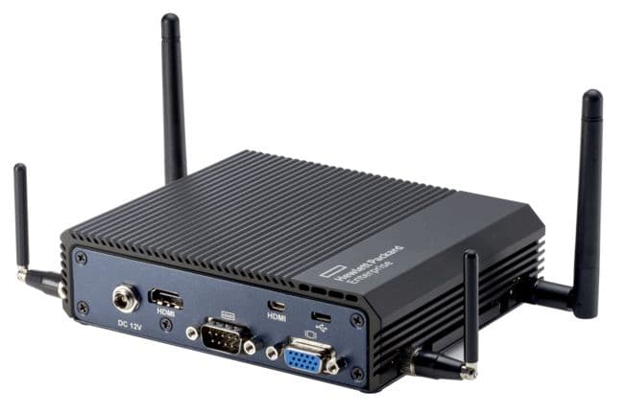Being a network node, the **gateway** is used in telecommunications and connects two networks having different transmission protocols together. They may consist of rate converters, signal translators, impedance matching devices, protocol translators, or fault isolators. Mutually acceptable administrative methods need to be established between the two networks. They also perform required protocol conversions.